***Task 4- testing***

For the testing part I tested the classes that are related to each use case separately, first of all, use case 01: Transfer registered vehicle, related classes:

1. Vehicle
2. Owner
3. Register-Sticker
4. Invoice

For the 4 classes I made 2 Junit tests one for the full parametrized constructors and one with the empty constructors.

Vehicle tests: 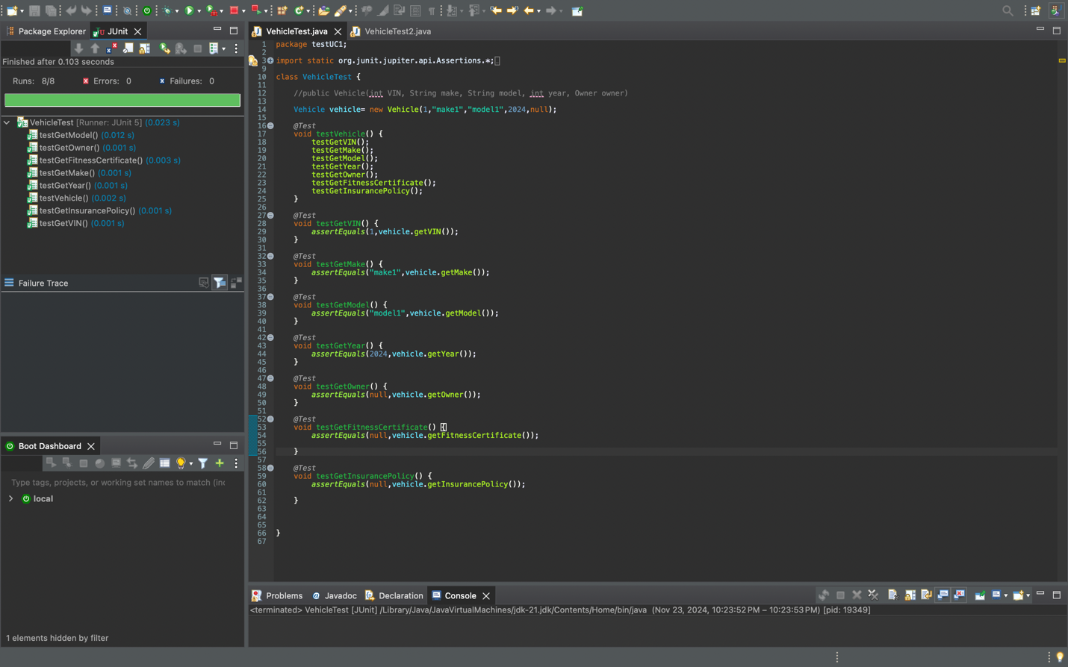

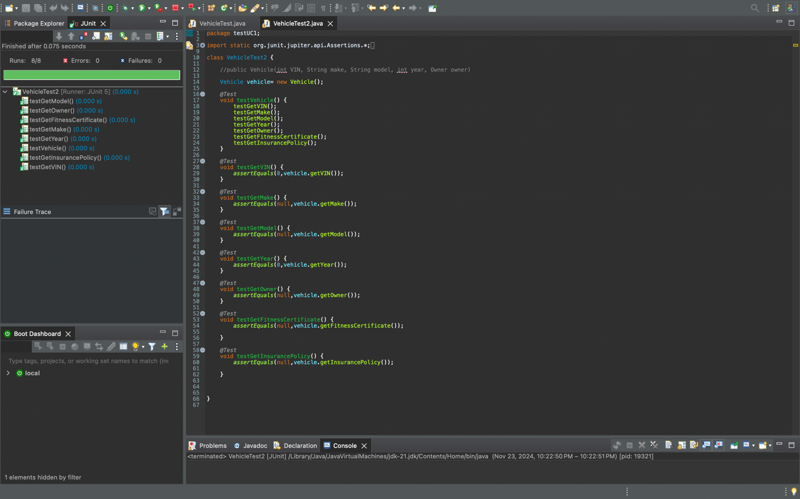

Owner class tests: 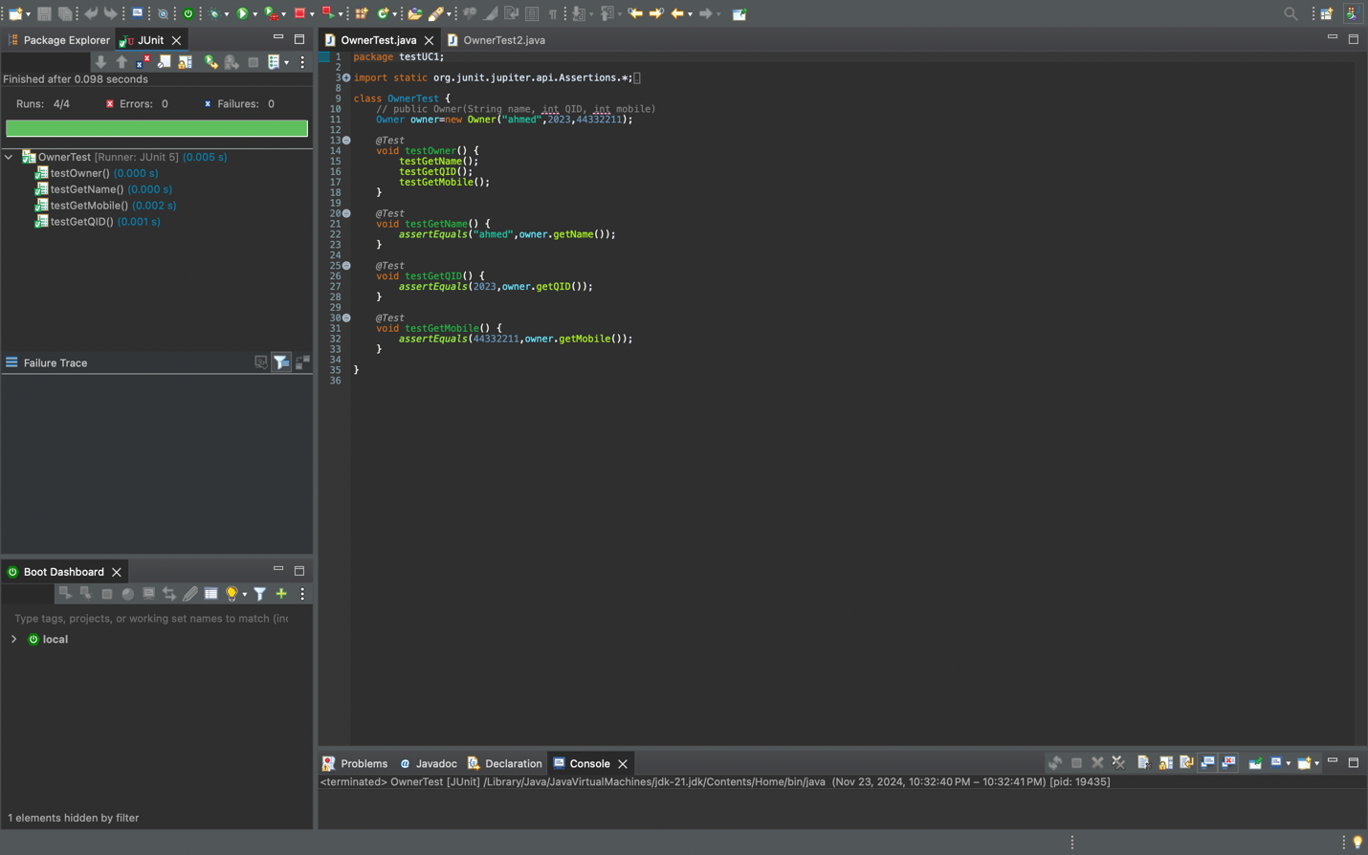

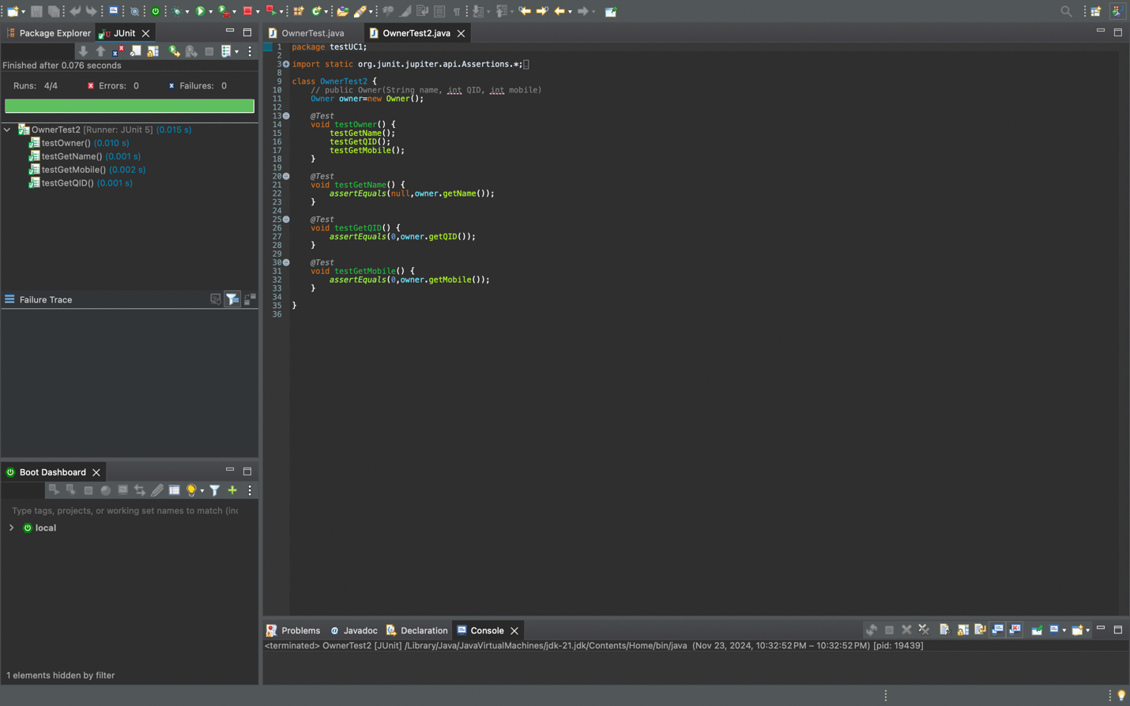

Registration sticker class tests: 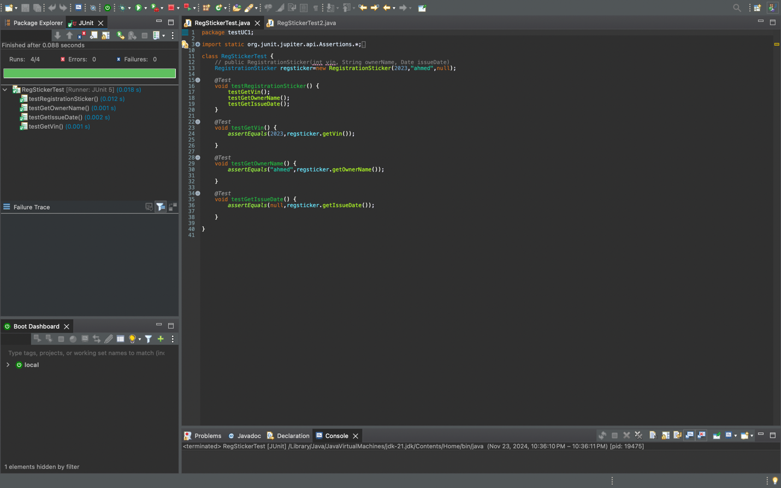

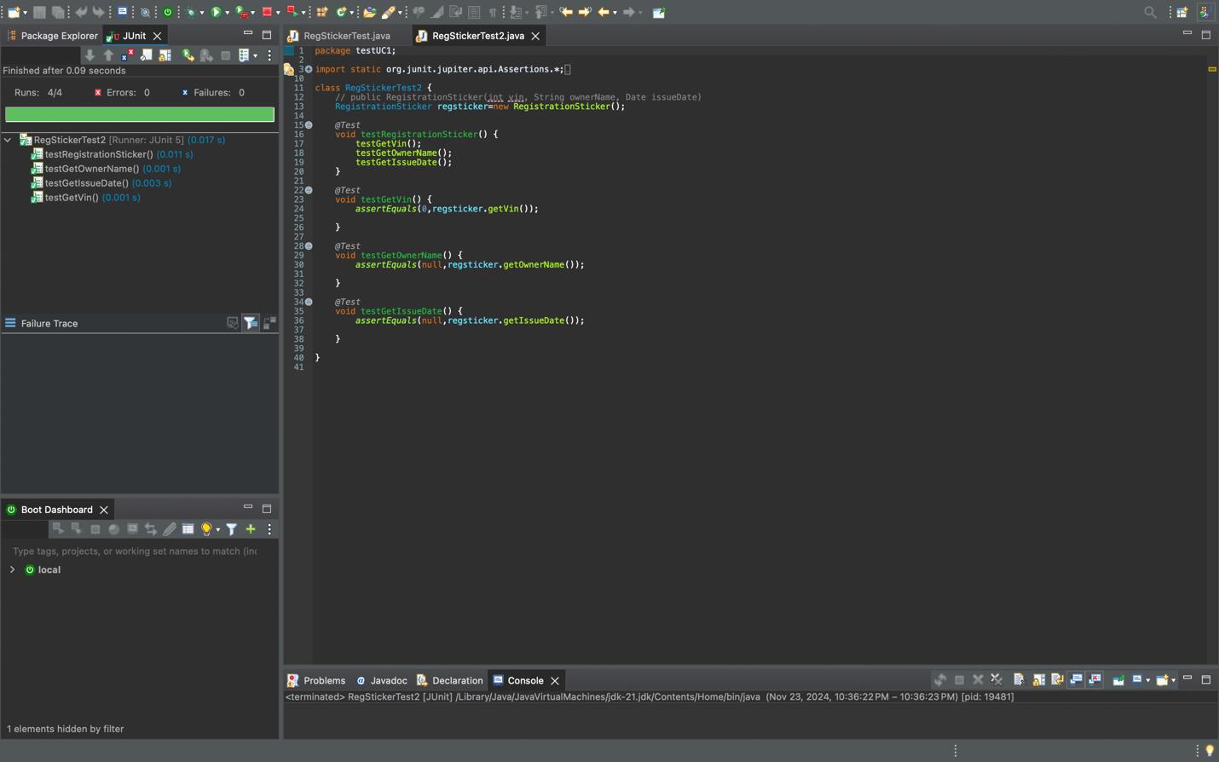

Invoice class tests: 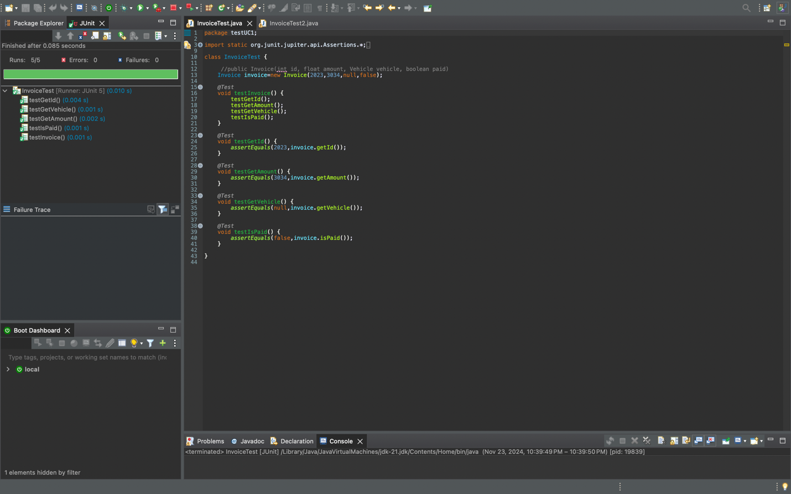

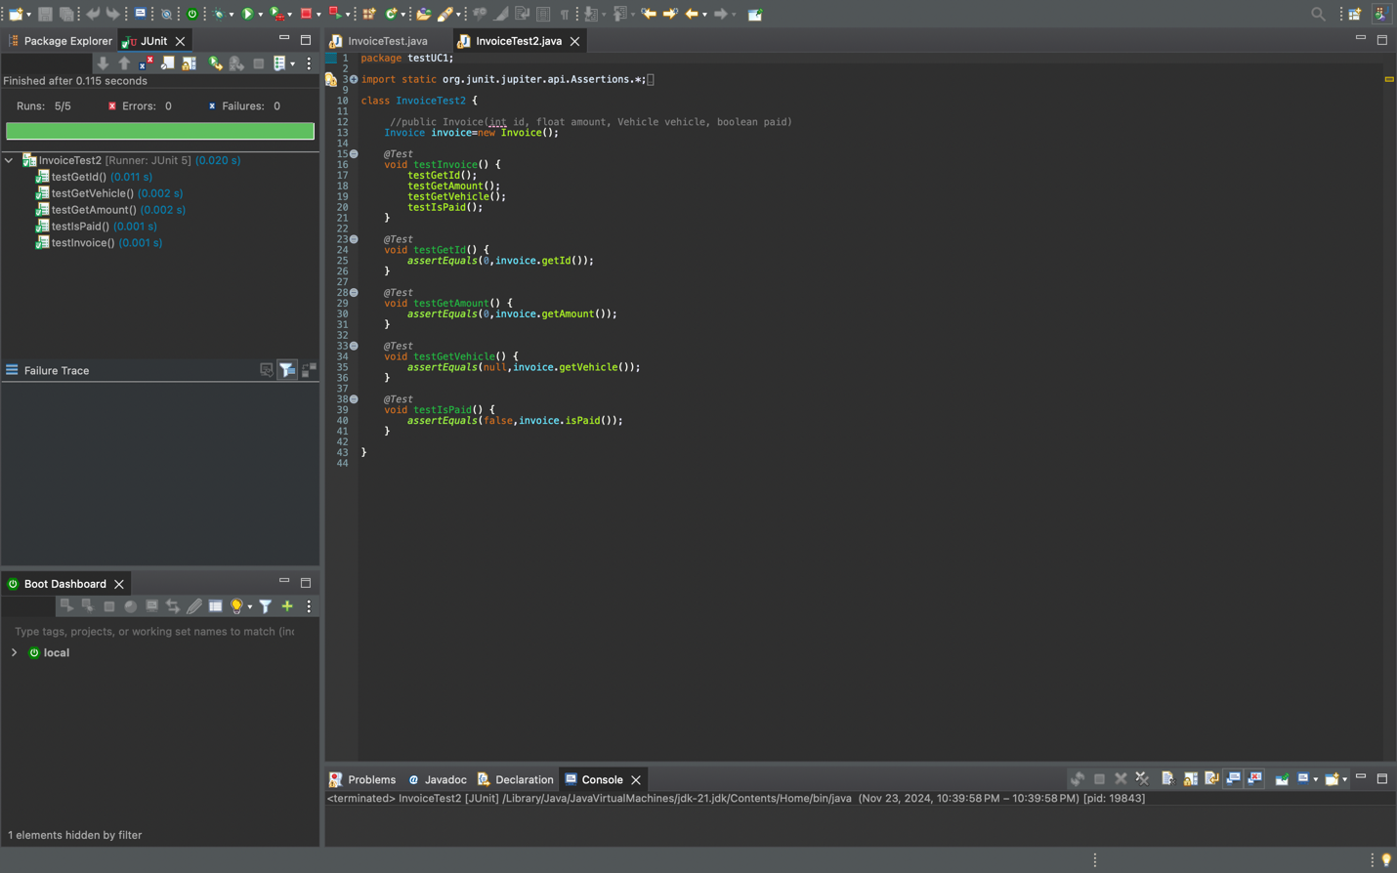

And for the use case 2: Manage accident, related classes:

1. Insurance Company
2. Vehicle (was tested in the first use case too also but I added it for the sake of clarity)
3. Owner(same as vehicle)
4. Accident
5. Insurance Policy
6. Accident Report

Insurance Company tests: 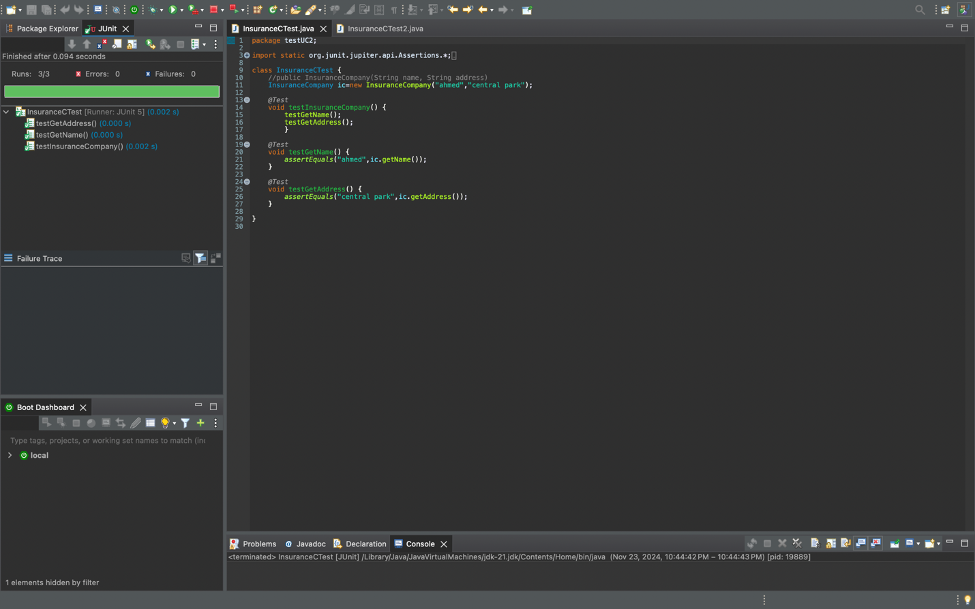

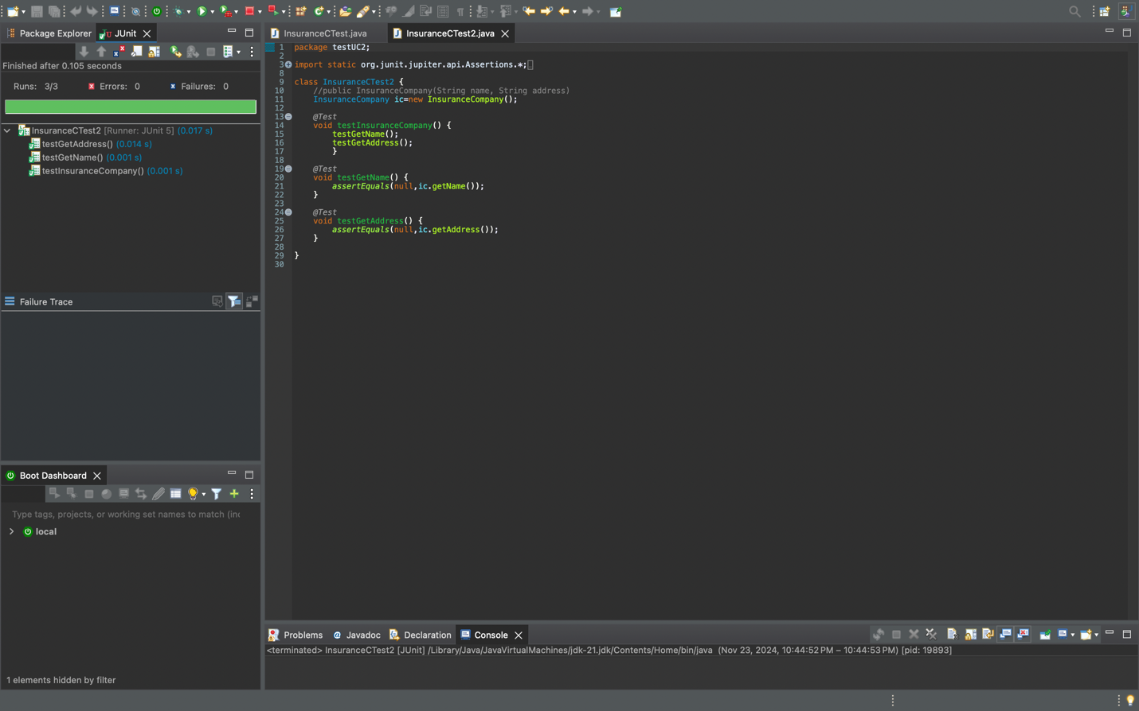

Accident class tests:

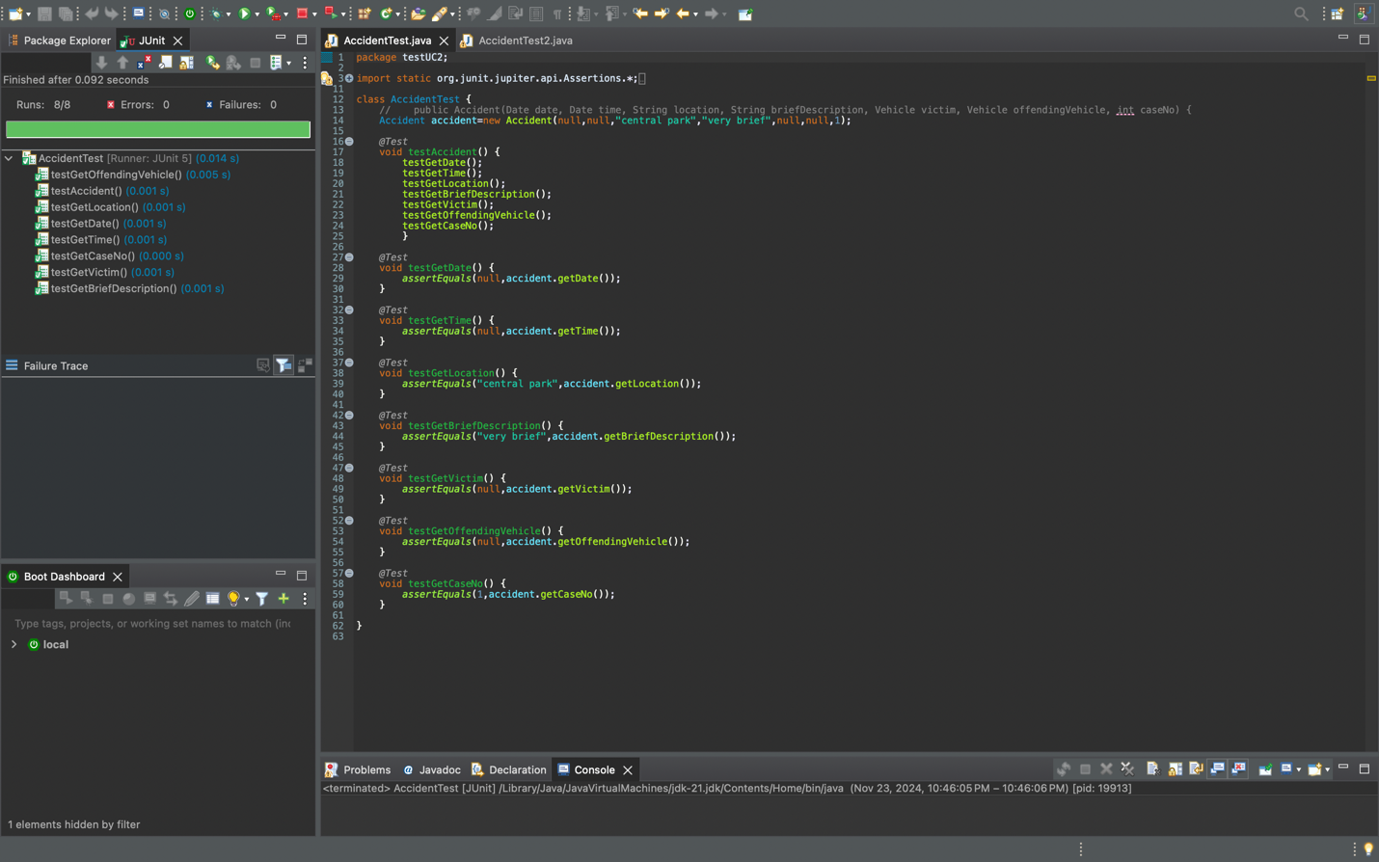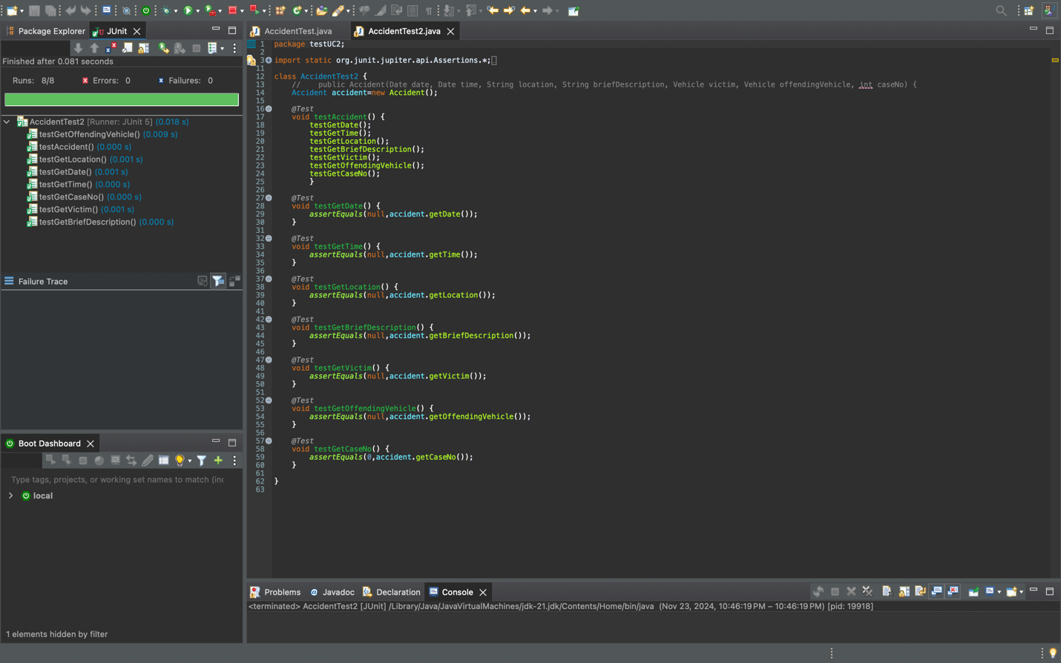

Insurance policy class tests:

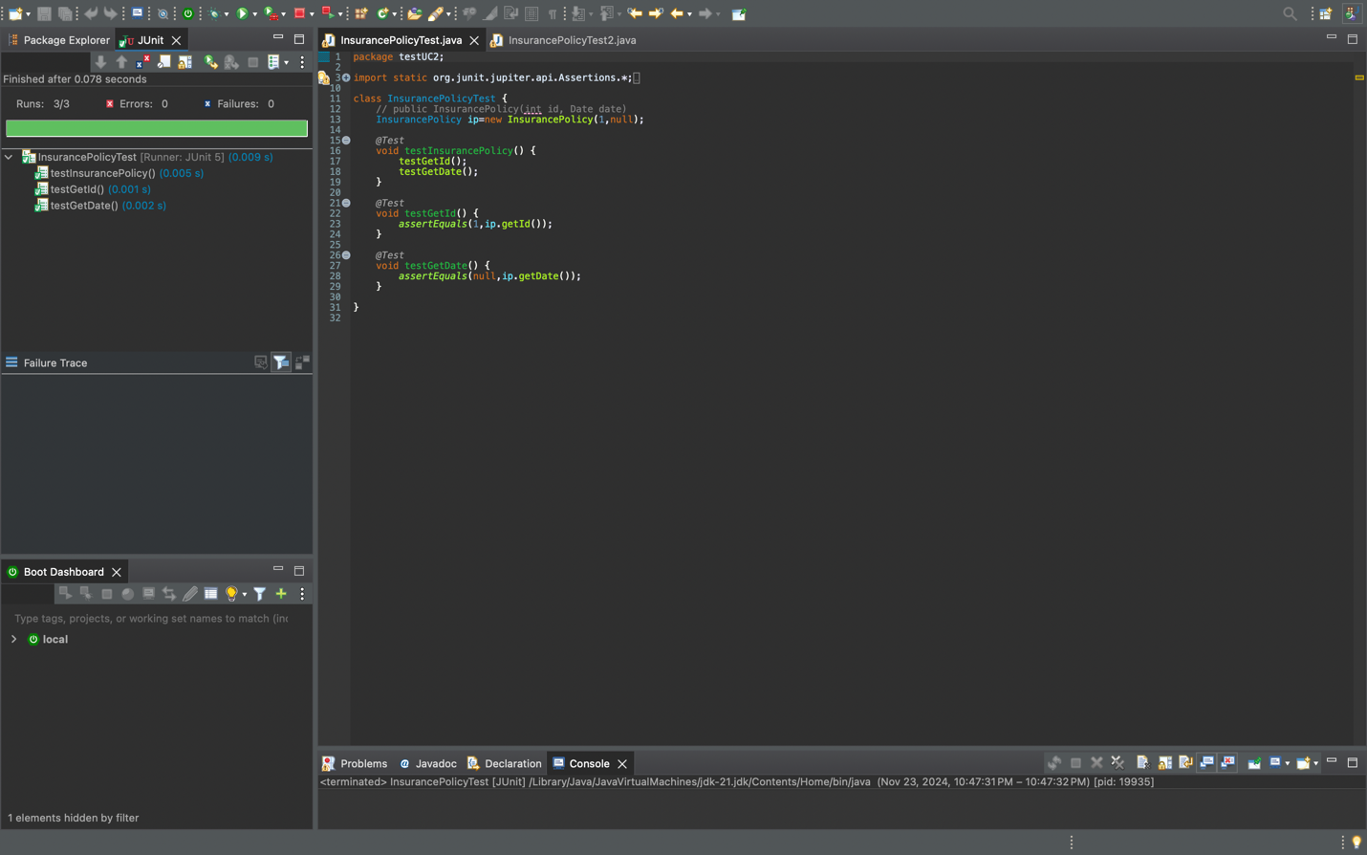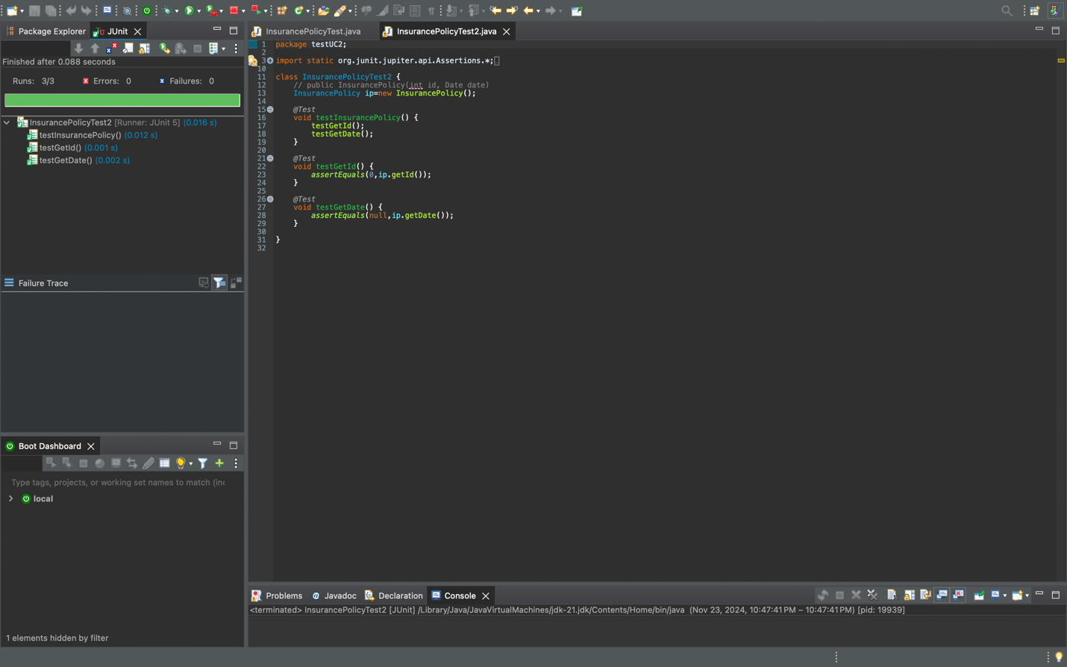

Accident report class tests:

